Project 2.3 — Automating Docker Image Builds using Jenkins CI/CD Pipeline

Task 1 - Prepare the Application Repository
Create or use an existing application repository that contains:
- Application source code
- ﻿﻿Dockerfile
- ﻿﻿Project dependencies
Push the repository to Github.
Using the Existing repo : https://github.com/SnehalShinde11/docker-microservices-app.git

Let's verify the repository :
We need to make sure the GitHub remote is already configured.
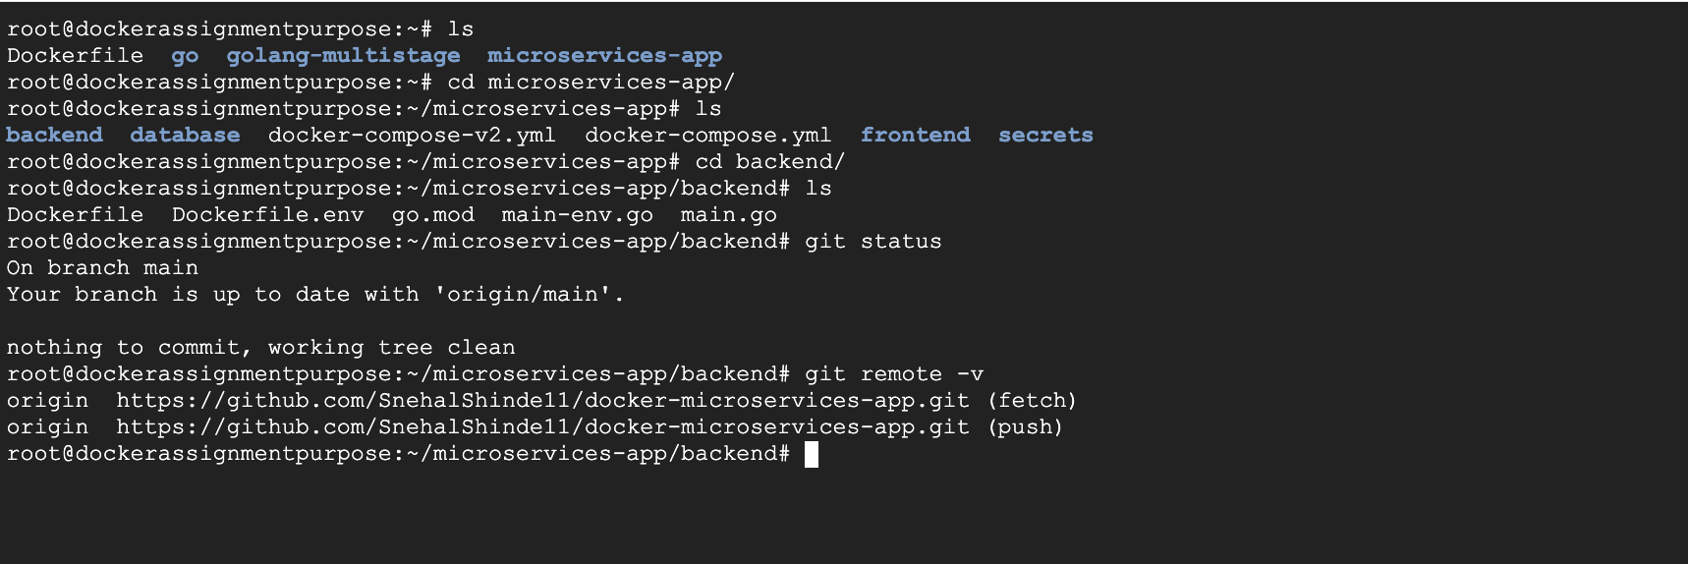

Task 2 - Setup Jenkins Environment
Install and configure Jenkins on the server.
In order to install jenkins follow below steps :
#apt update
#apt install -y fontconfig openjdk-21-jre

Verify : java -version
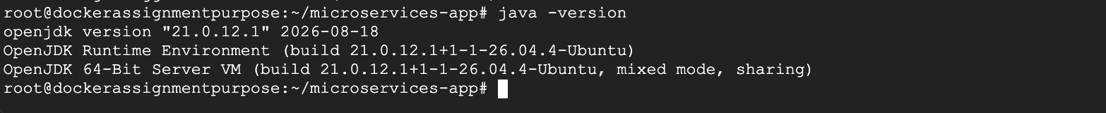

2. Add the Jenkins repository
Run:
#curl -fsSL https://pkg.jenkins.io/debian-stable/jenkins.io-2026.key \
-o /usr/share/keyrings/jenkins-keyring.asc
Then:

#echo "deb [signed-by=/usr/share/keyrings/jenkins-keyring.asc] https://pkg.jenkins.io/debian-stable binary/" \
> /etc/apt/sources.list.d/jenkins.list

Update: apt update

Install Jenkins: apt install -y jenkins

3. Start Jenkins: systemctl enable --now jenkins
Check: systemctl status jenkins --no-pager
4. Verify Jenkins #jenkins --version
And: ss -lntp | grep 8080
Jenkins should be listening on:8080

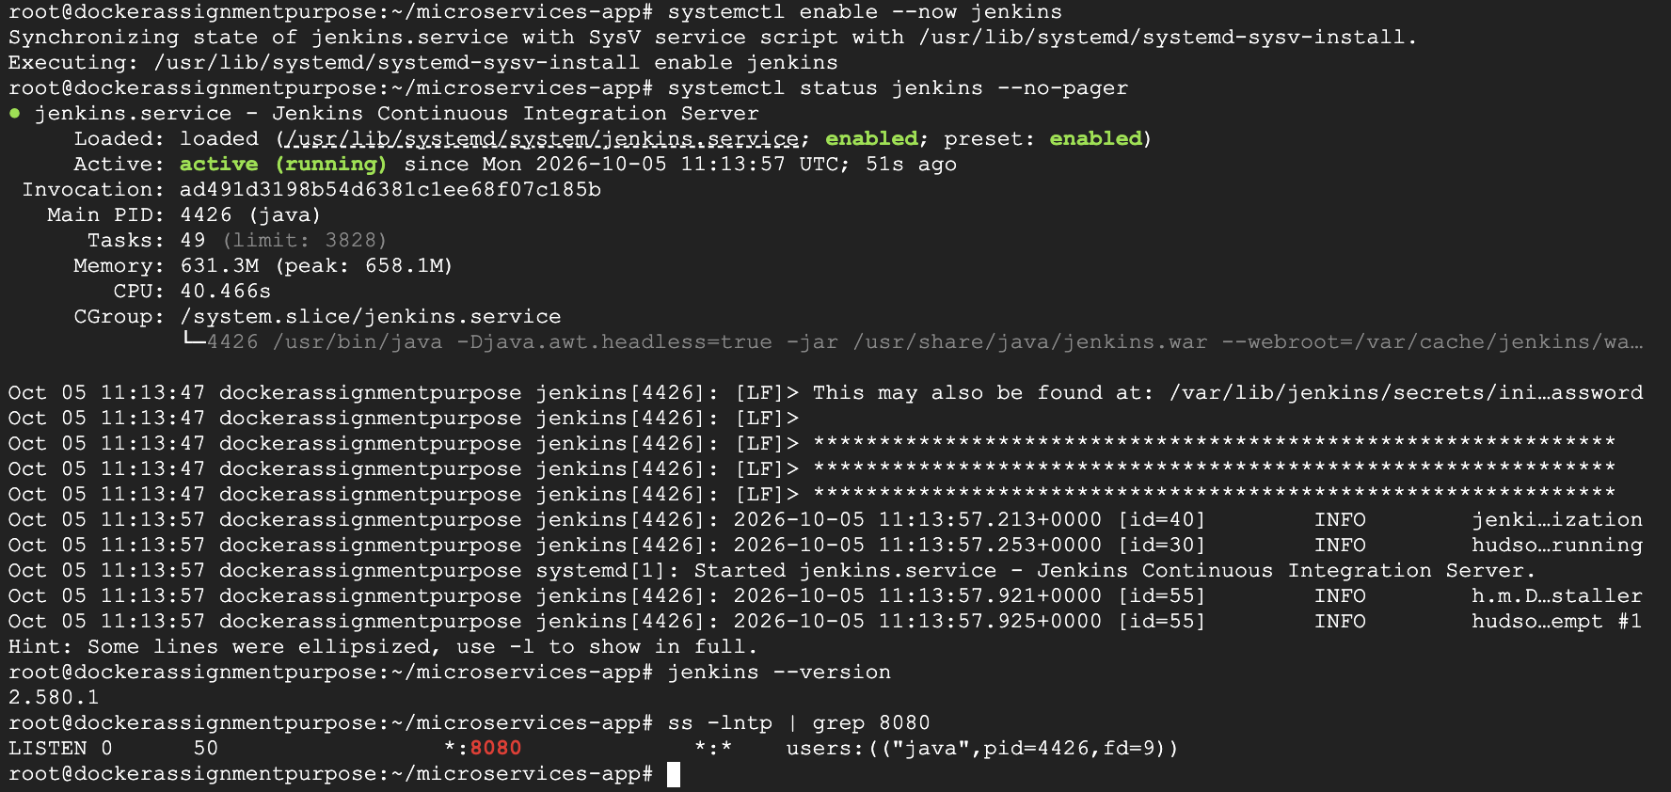

Important: give Jenkins Docker access
Once Jenkins is installed, run:#usermod -aG docker jenkins
Then:systemctl restart jenkins
Verify the Jenkins user: id jenkins
You should see docker in its groups.
Then test Docker access as the Jenkins user:
su -s /bin/bash jenkins -c 'docker ps'
It should execute successfully without a Docker permission error.
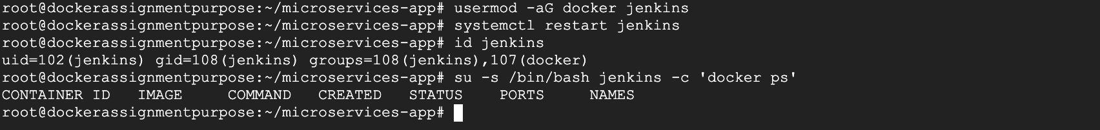

Now in order to access the Jenkins UI :
First get the Jenkins initial admin password:
#cat /var/lib/jenkins/secrets/initialAdminPassword
Also get the server IP: hostname -I
Then open in your browser: http://<SERVER-IP>:8080
Google Cloud Console → Compute Engine → VM instances
Add the VM's Network tags.jenkins-server

Make sure you have
2. Add a Google Cloud firewall rule
In Google Cloud Console:
VPC network → Firewall → Create firewall rule
Use approximately:
Name: allow-jenkins-8080

Direction: Ingress
Action: Allow
Targets: your Jenkins VM / appropriate network tag
Source IPv4 ranges: YOUR_PUBLIC_IP/32 [This will from which machin you will be accessing the UI]
In my case : 58.84.60.118/32
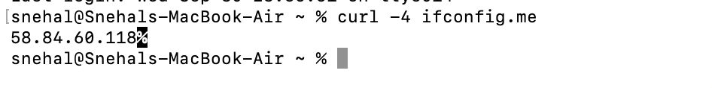

Protocols and ports:
TCP: 8080

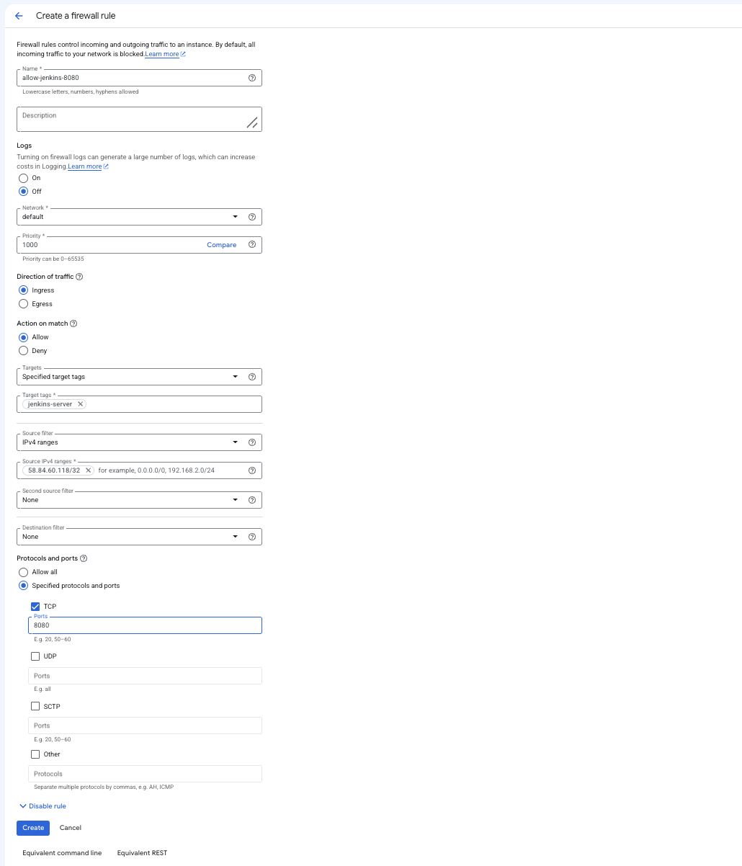

Once this is completed :
Access it on web browser using : http://35.223.119.70:8080

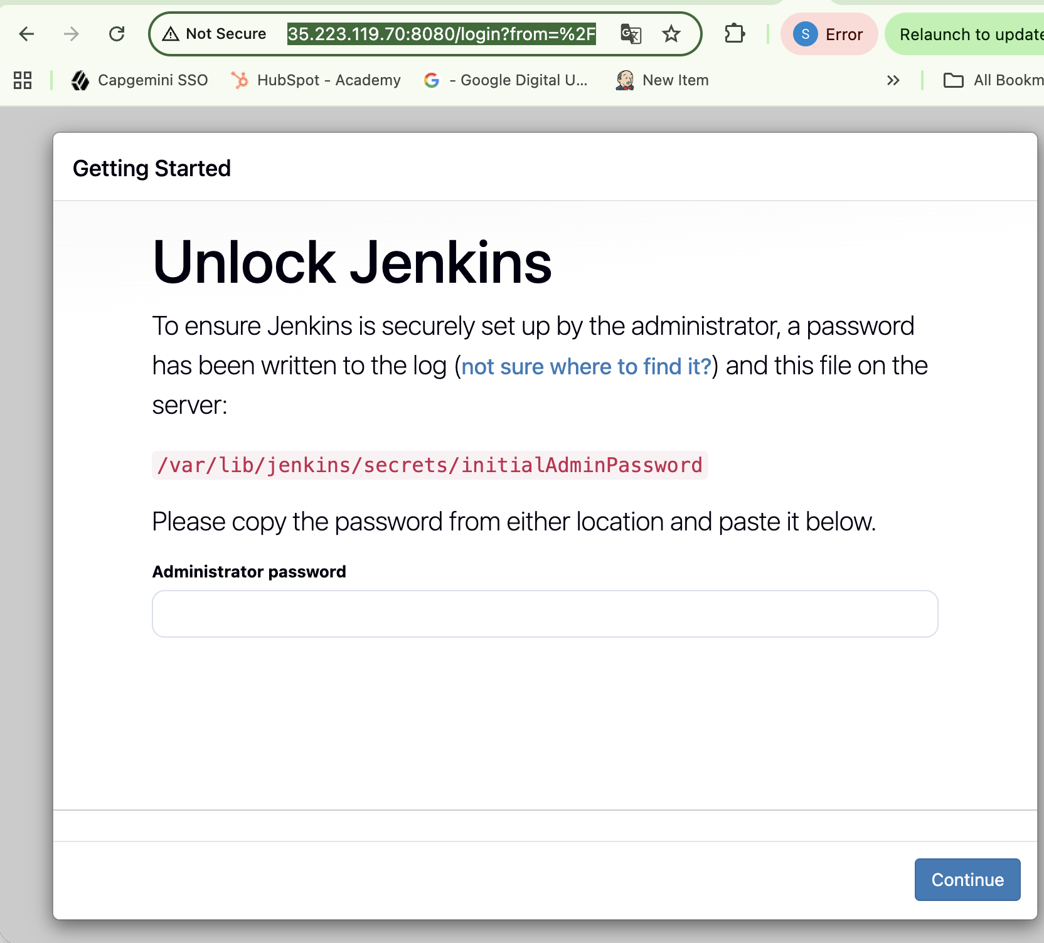
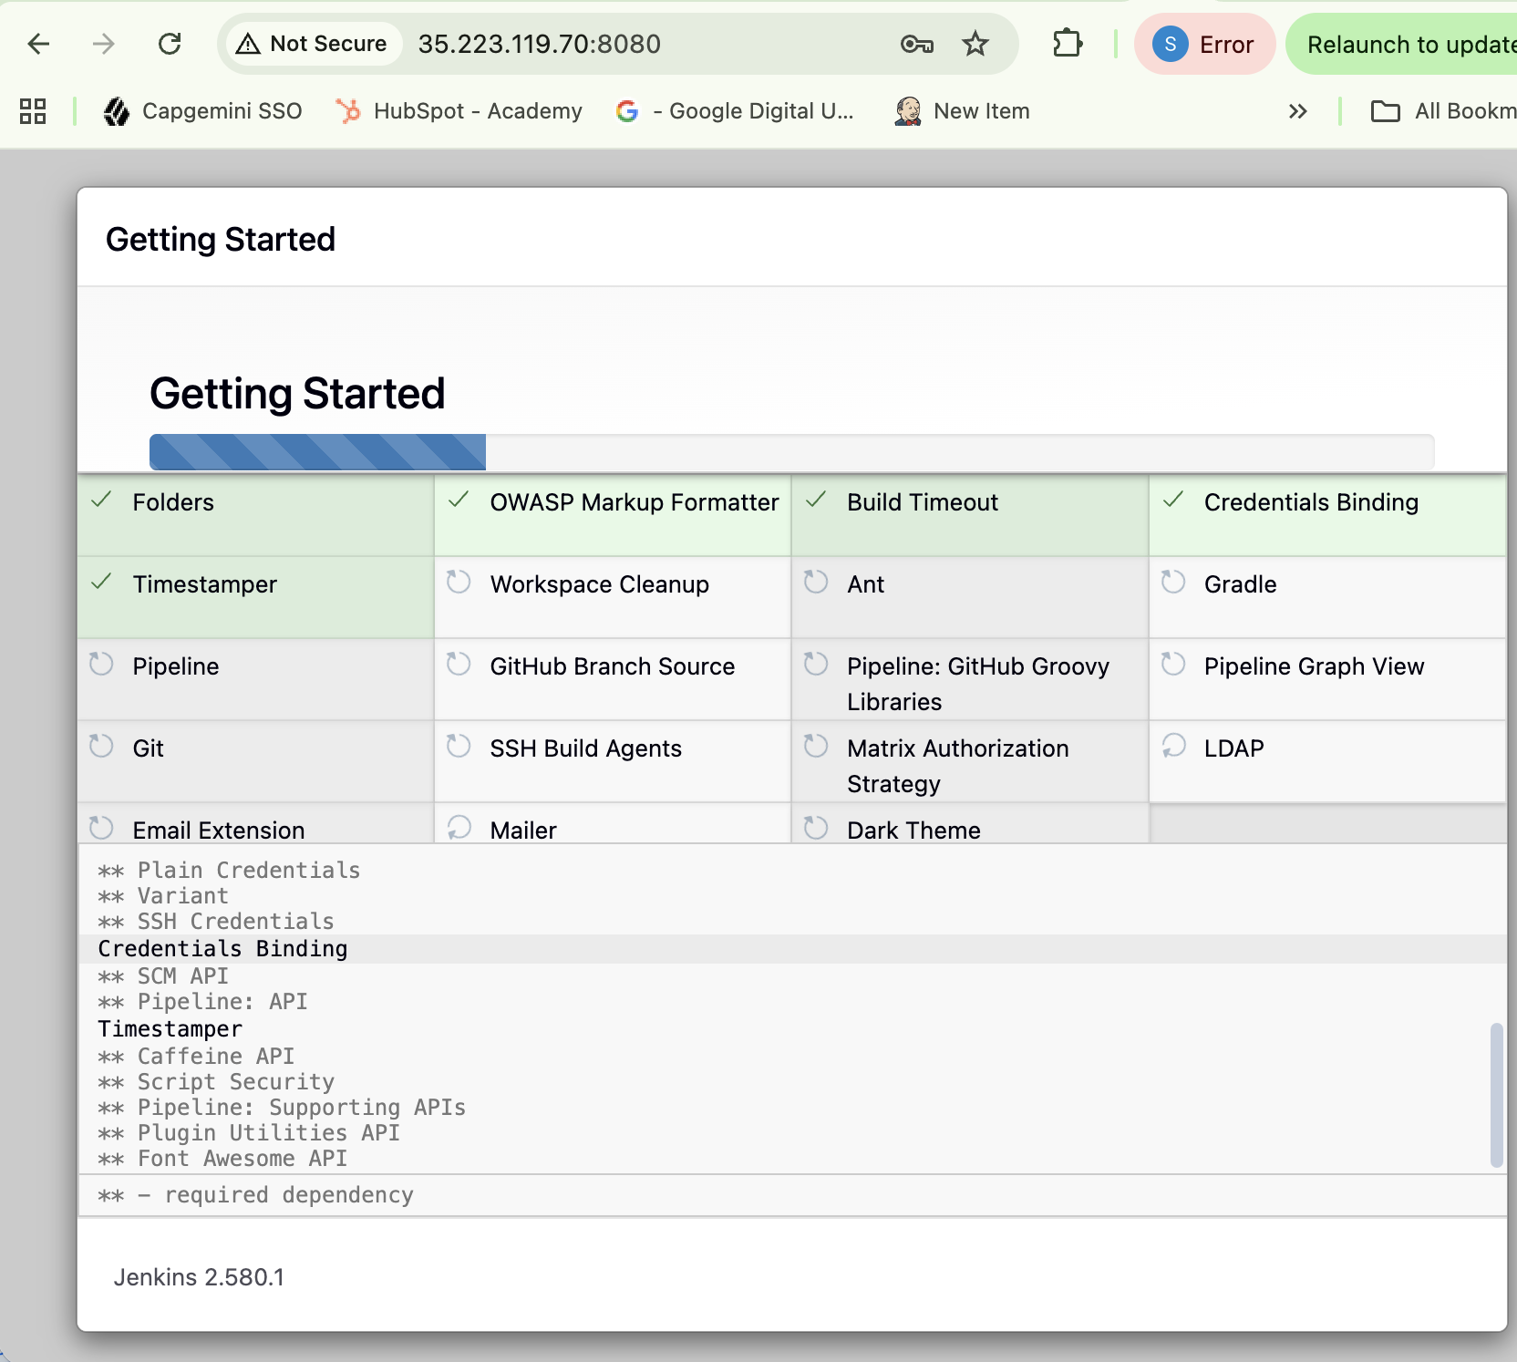
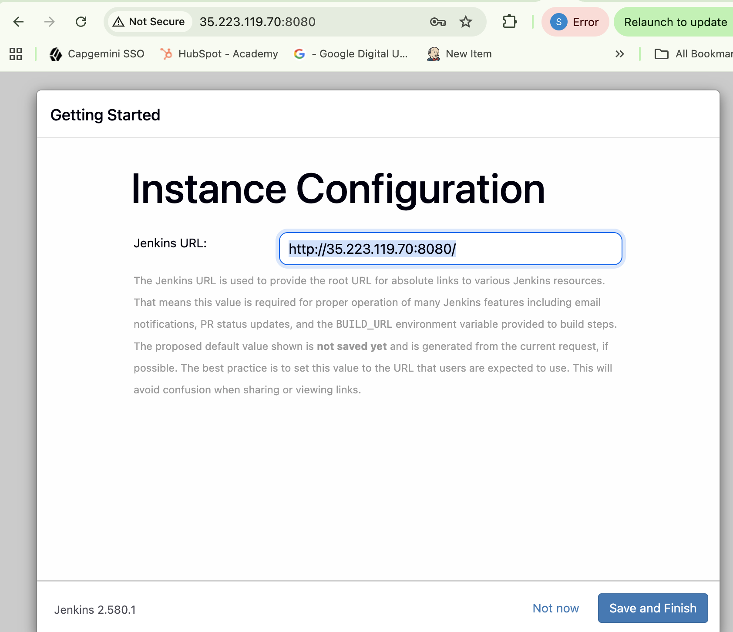
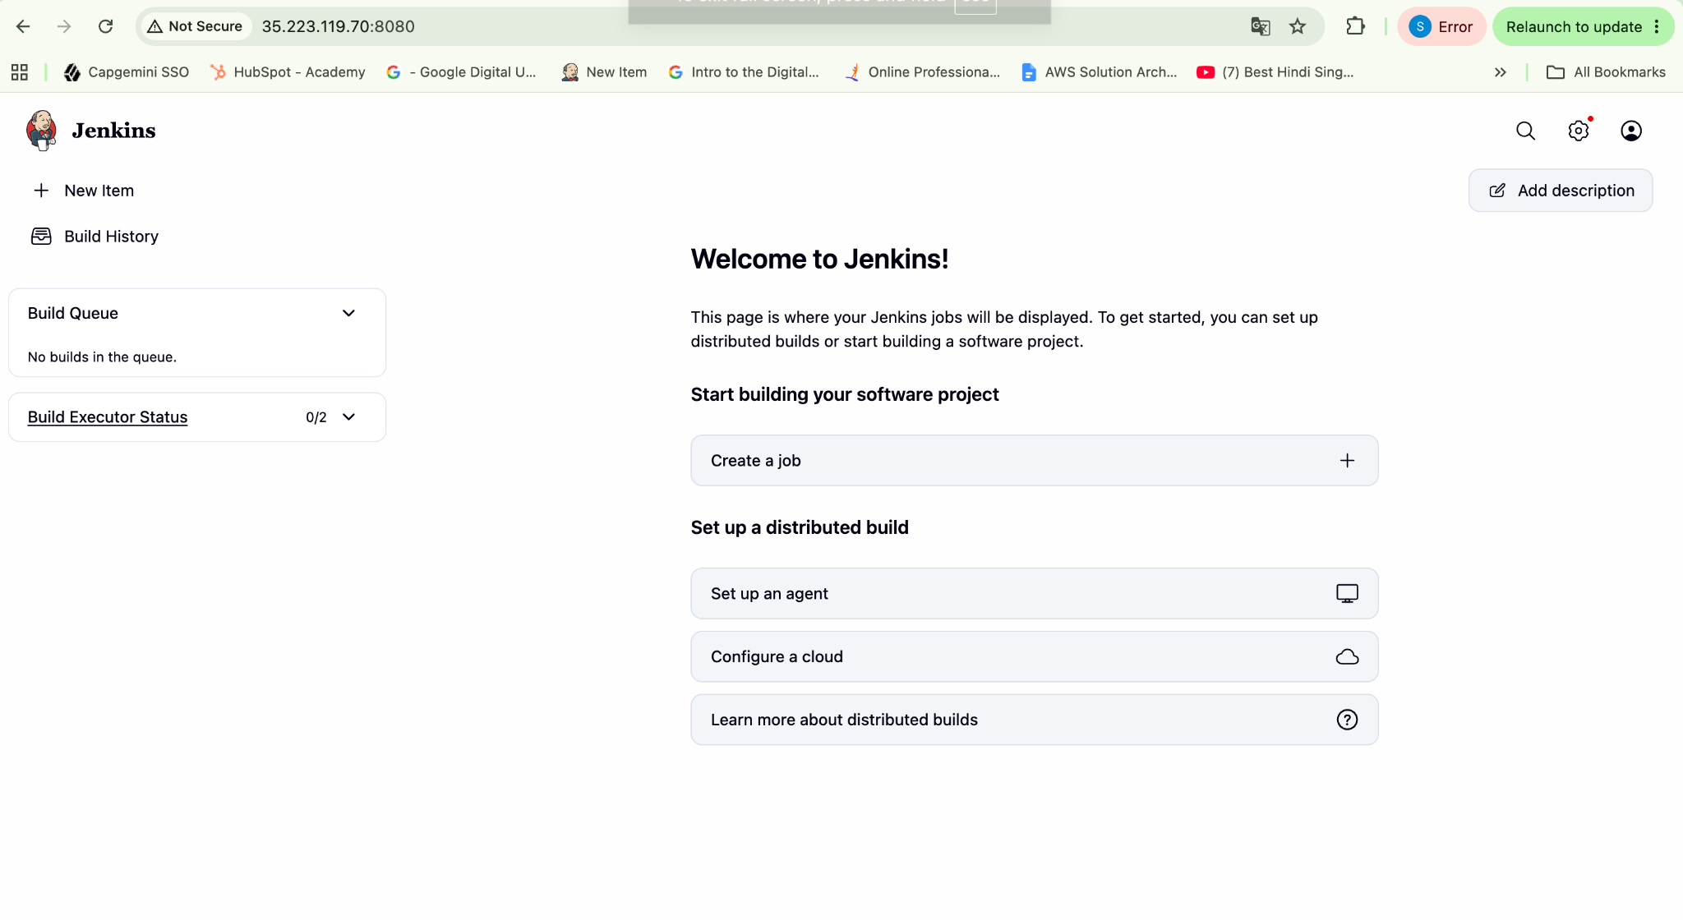

Ensure Jenkins has access to:
﻿﻿Docker engine
﻿﻿GitHub repository
﻿﻿Container registry credentials

You can validate access using :
#For ﻿﻿Docker engine.
Step 1: Check Jenkins user belongs to Docker group
id jenkins
You should see: uid=102(jenkins) gid=108(jenkins) groups=108(jenkins),107(docker)
Step 2: Test Docker as Jenkins user
Run: su -s /bin/bash jenkins -c 'docker ps'
Step 3: Verify Docker version as Jenkins
su -s /bin/bash jenkins -c 'docker version'

﻿﻿#For GitHub repository
Step 2: Test GitHub access from the VM
Run:git ls-remote https://github.com/SnehalShinde11/docker-microservices-app.git

#For ﻿﻿Container registry credentials.
1. Open Jenkins Credentials
From the Jenkins dashboard: Manage Jenkins → Credentials
Then under Stores scoped to Jenkins, click: Jenkins → Global credentials (unrestricted)
Then click: Add Credentials

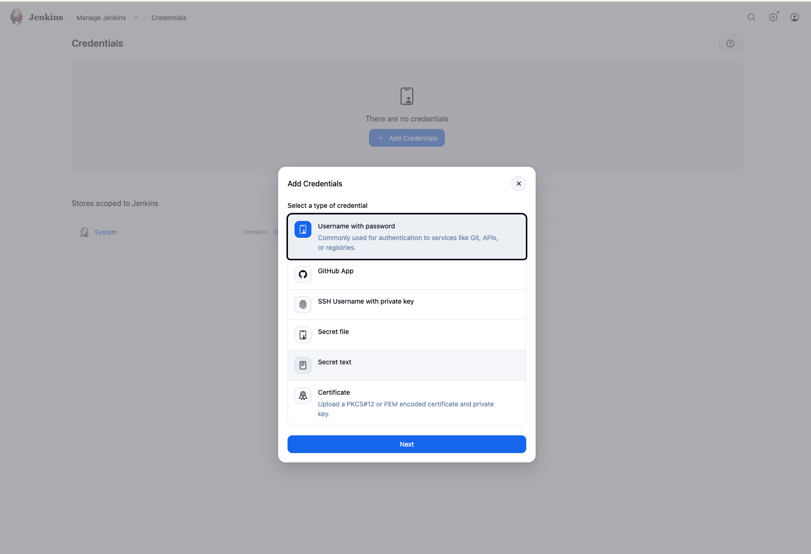

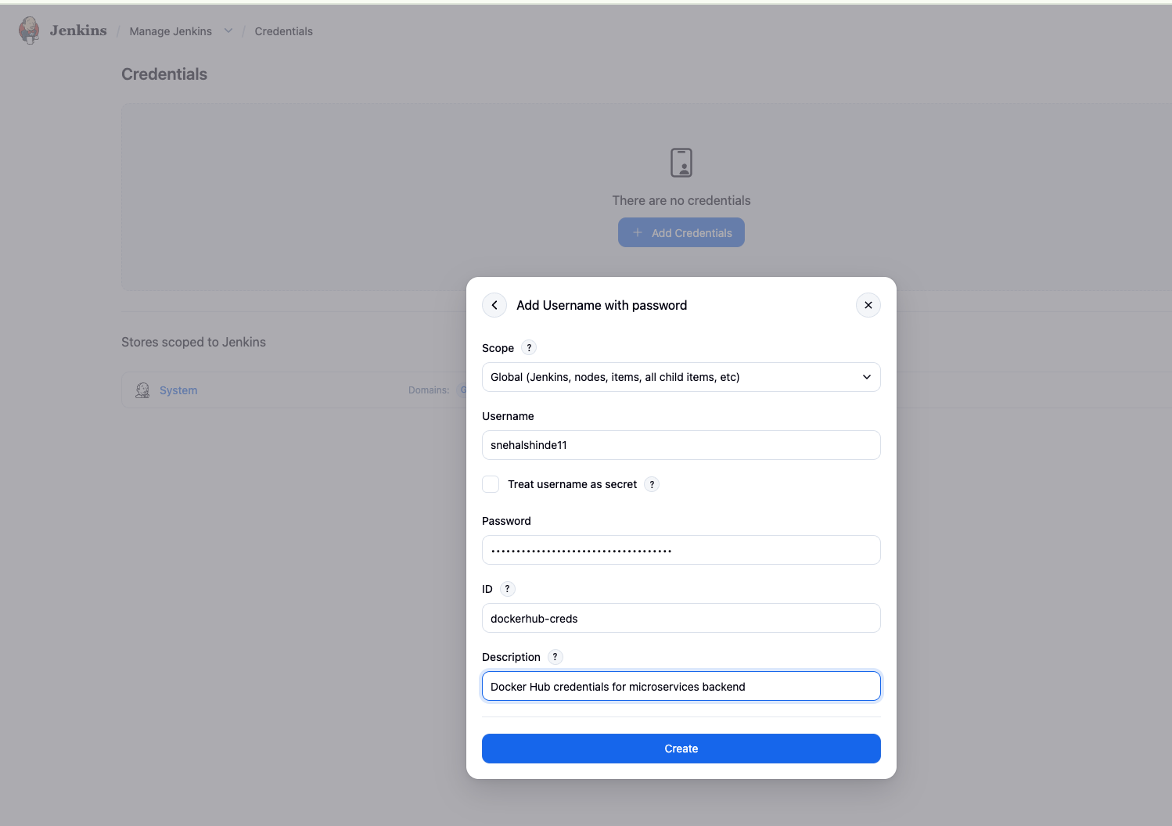
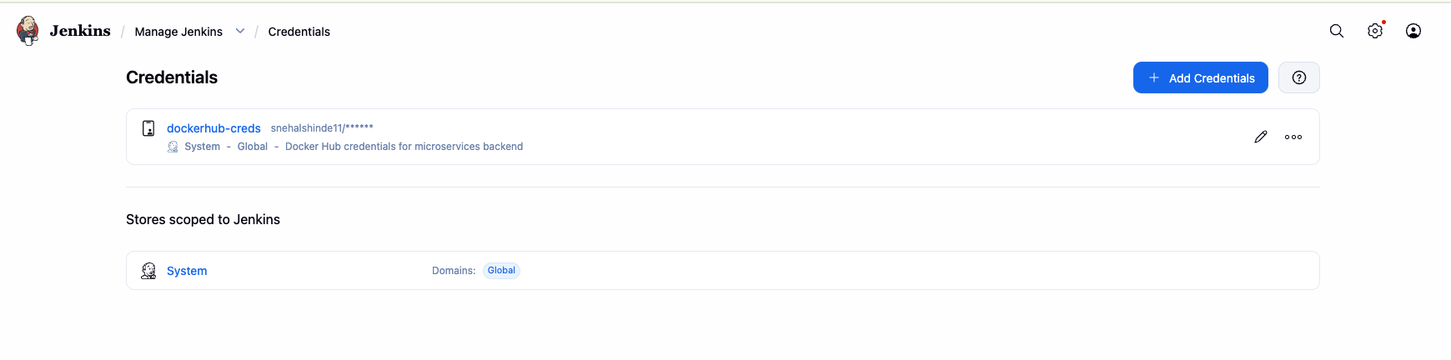

3. What should you use as the password?
Docker Hub Personal Access Token (PAT) rather than your Docker Hub account password.
On Docker Hub: Account Settings → Personal access tokens → Generate new token
Give it permission to push images to your repository.
Then copy that token directly into the Jenkins Password field.

Task 3 - Create Jenkins Pipeline Job
Create a Jenkins pipeline job that will automate the CI process.
Configure Jenkins to connect to the GitHub repository.
From Jenkins Dashboard: New Item
Enter: microservices-backend-ci
Select:Pipeline , Then click OK.
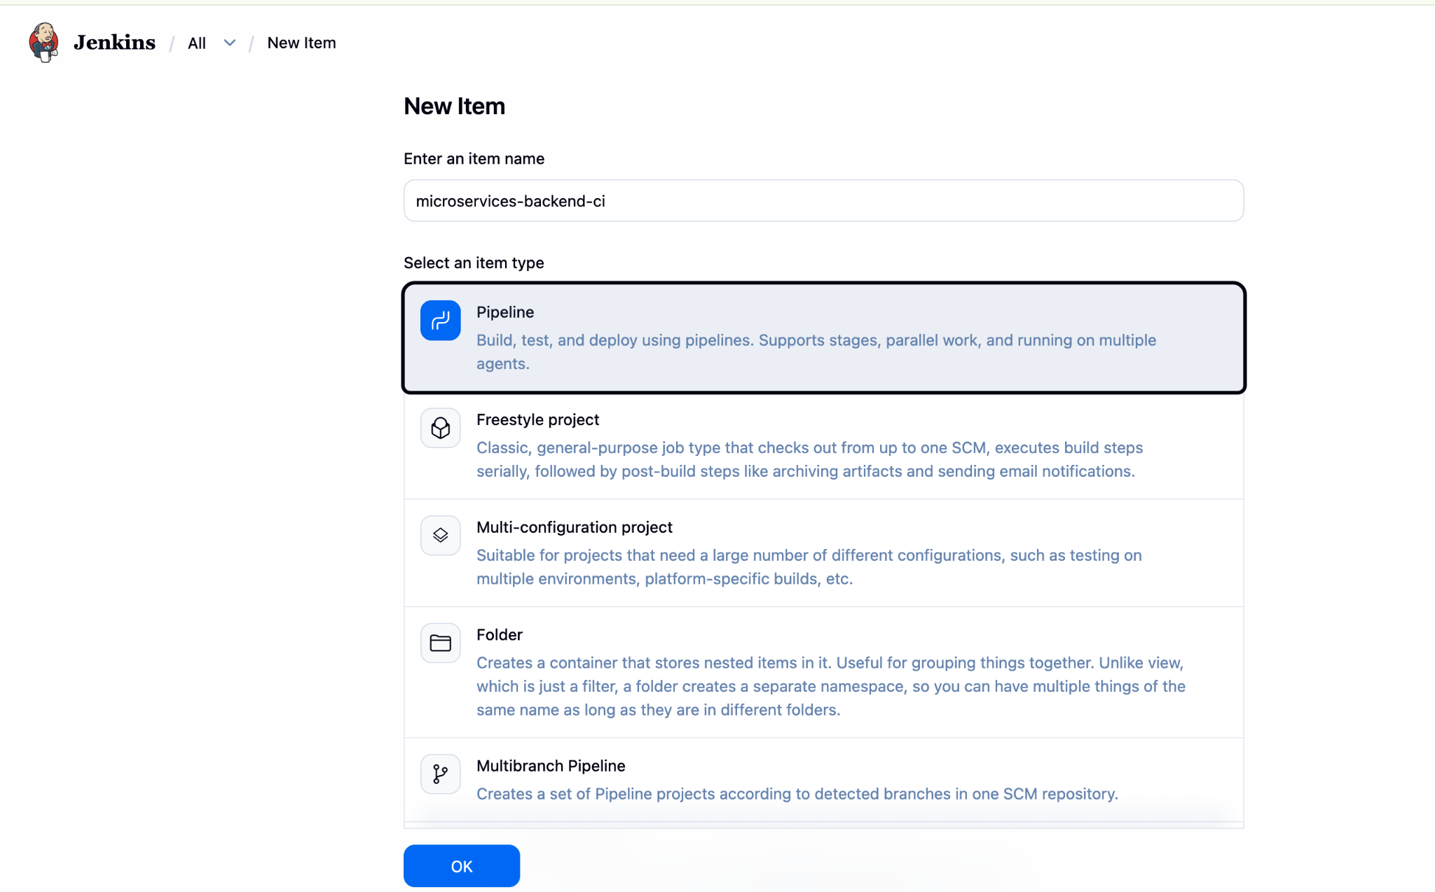

Step 2 — Configure the Pipeline
Scroll down to the Pipeline section.
Set:
Definition:
Pipeline script from SCM
Then:SCM: Git
Repository URL:
https://github.com/SnehalShinde11/docker-microservices-app.git
Because your repository is public, leave Credentials as - none -.
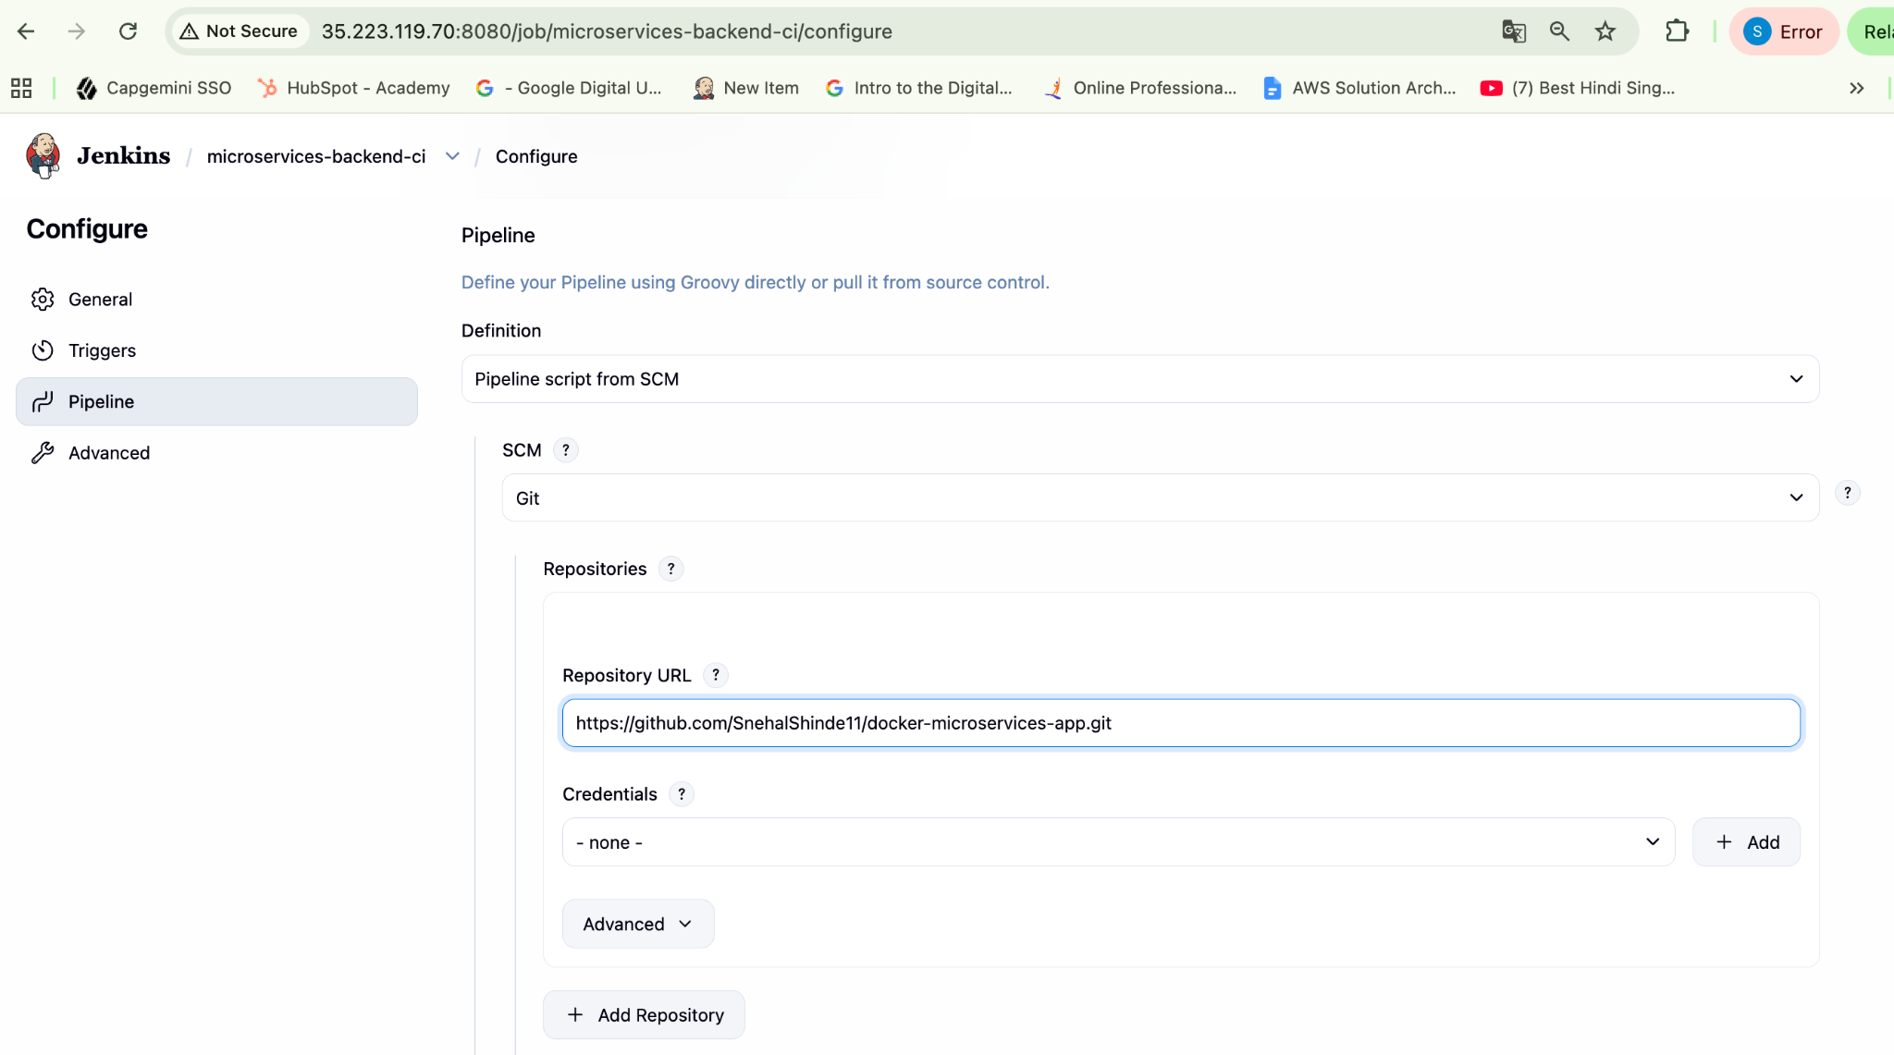
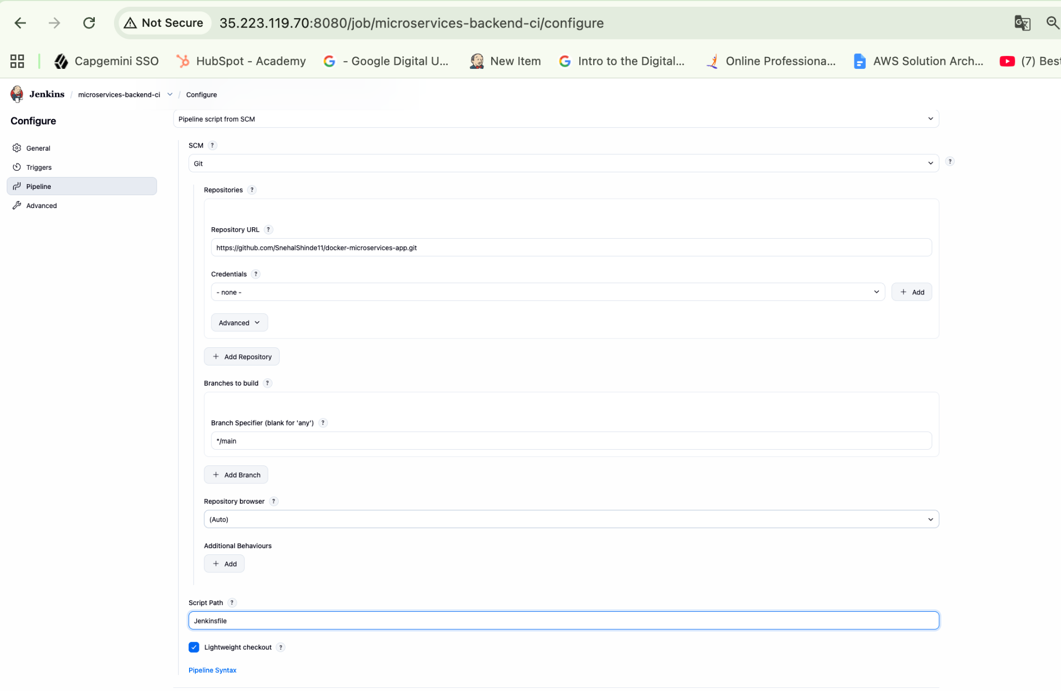

Pipeline Definition: Pipeline script from SCM
SCM: Git
Repository URL: https://github.com/SnehalShinde11/docker-microservices-app.git
├── Credentials: - none -
├── Branch: */main
└── Script Path: Jenkinsfile
Save:

Task 4 - Define Pipeline Stages
Design the Jenkins pipeline with stages such as:
- ﻿﻿Source code checkout
- ﻿﻿Application build
- ﻿﻿Docker image build
- ﻿﻿Image tagging
- ﻿﻿Image publishing
Jenkinsfile is pushed to repo : https://github.com/SnehalShinde11/docker-microservices-app/blob/main/Jenkinsfile

Task 5 - Build Docker Image Automatically
Configure the pipeline so that it builds a Docker image from the Dockerfile stored in the repository.
Each build should generate a new version of the Docker image.

Task 6 — Push Image to Docker Hub
Configure the pipeline to push the built Docker image to Docker Hub.
Ensure proper authentication with the container registry.

Task 7 - Verify CI Pipeline Execution
Run the pipeline and verify that the process completes successfully.
Check that the Docker image is available in Docker Hub.

Task 5 and Task 6 has been configured in jenkinkfile :
Verification :

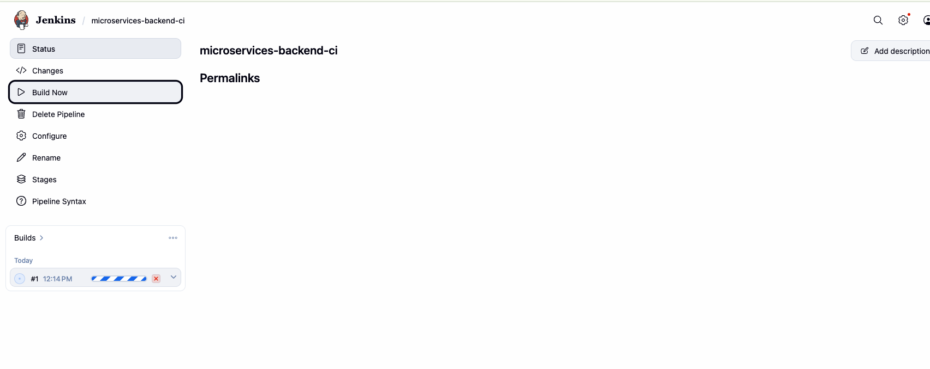
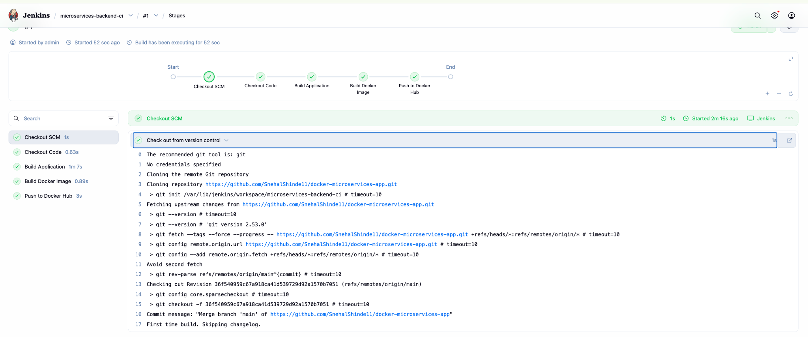
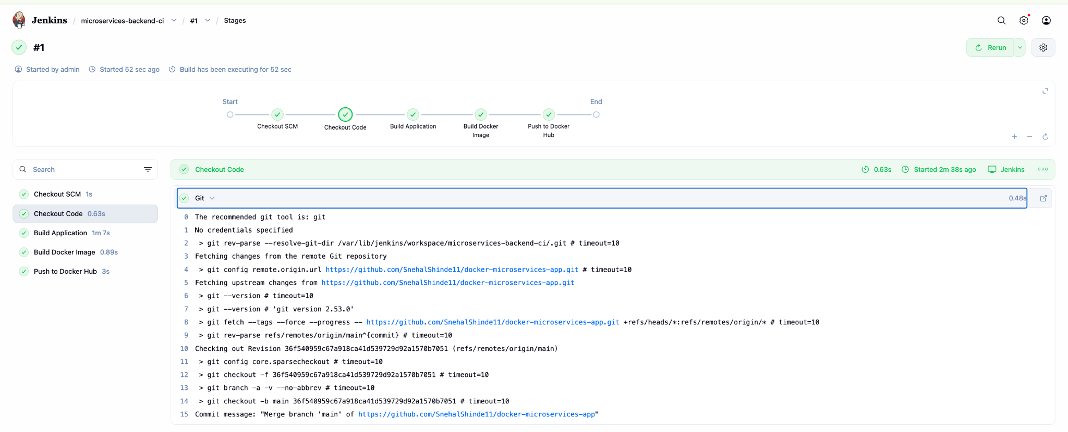
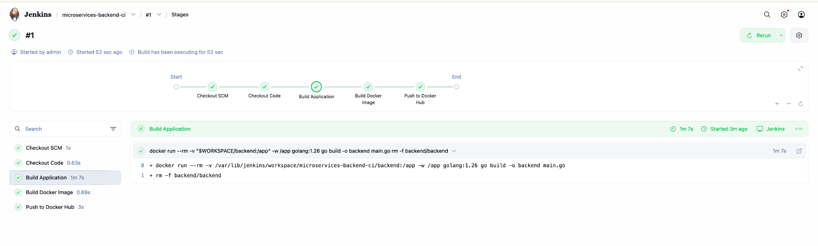

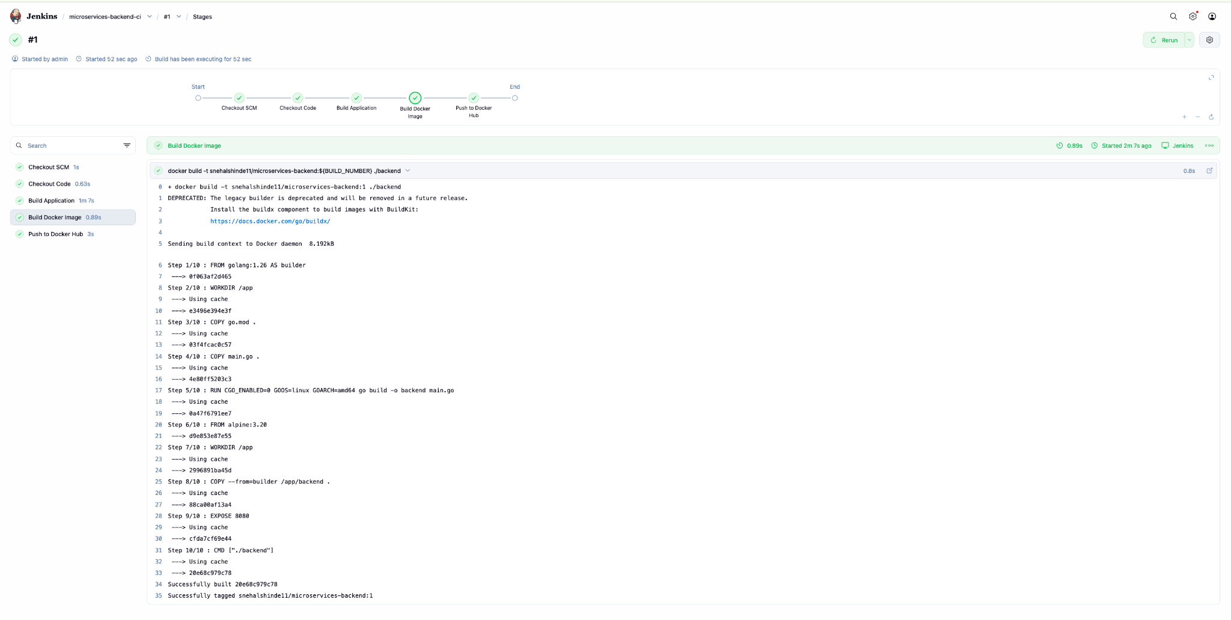
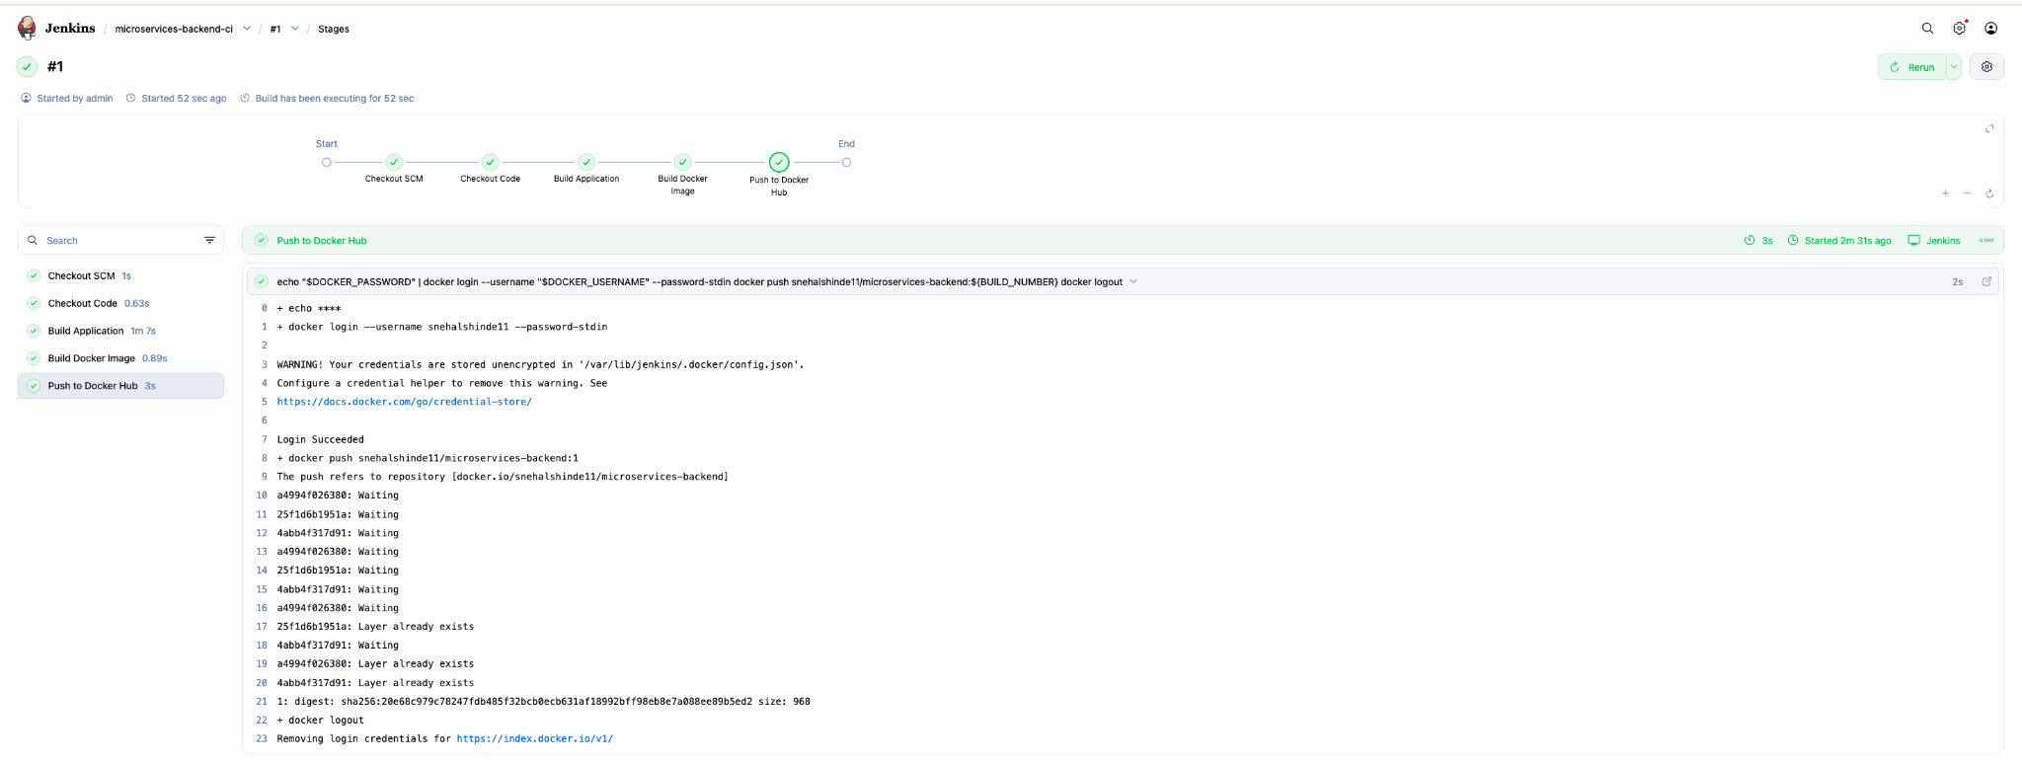

Validate on Dockerhub :
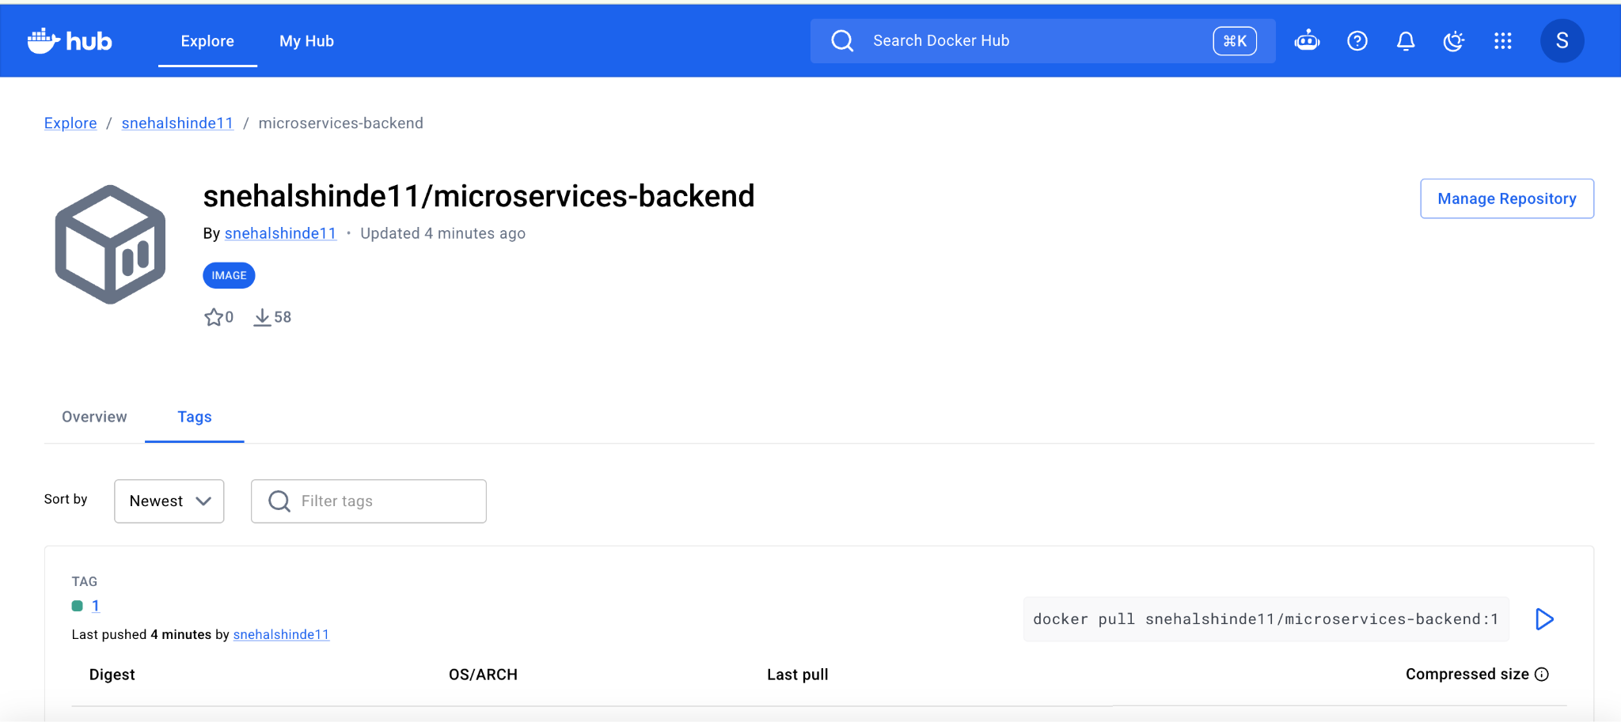

Lets try to build one more time and then see the tags are getting updated:

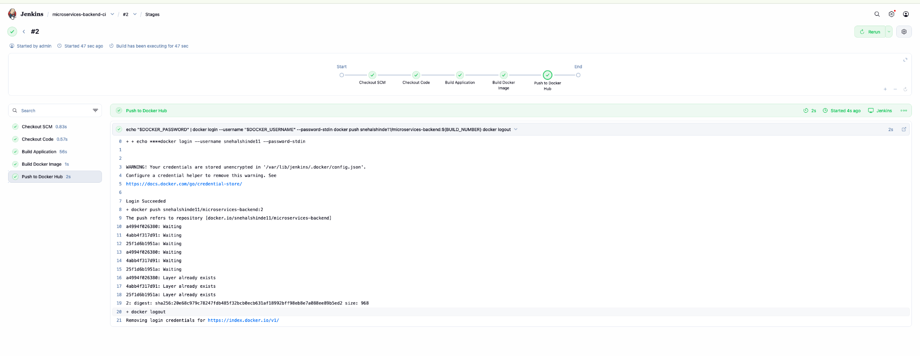
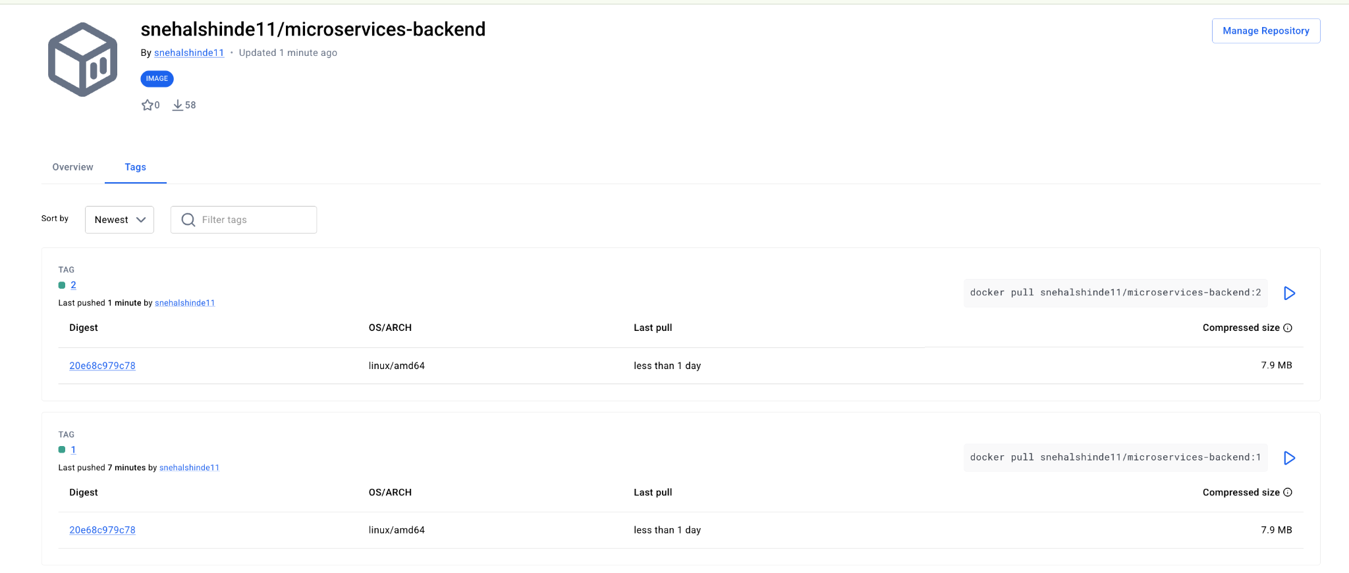

Beyond the Basics - Elevate Exercise
Enhance the CI pipeline by adding:
Automated pipeline trigger
1. Automated Pipeline Trigger — GitHub Webhook
A. Update Jenkins job
Open:Jenkins → microservices-backend-ci → Configure
Find Build Triggers. Enable: GitHub hook trigger for GITScm polling
Save.

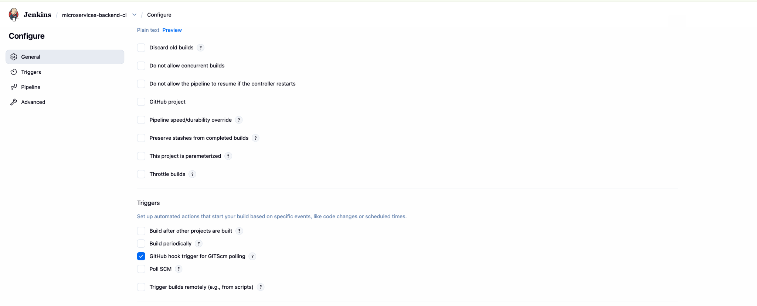

B. Create GitHub Webhook
Go to repository: docker-microservices-app on GitHub
Then: Settings → Webhooks → Add webhook
Use:
Payload URL
http://35.223.119.70:8080/github-webhook/
Content type
application/json
Which events?
Just the push event
Enable:
☑ Active
Click:
Add webhook

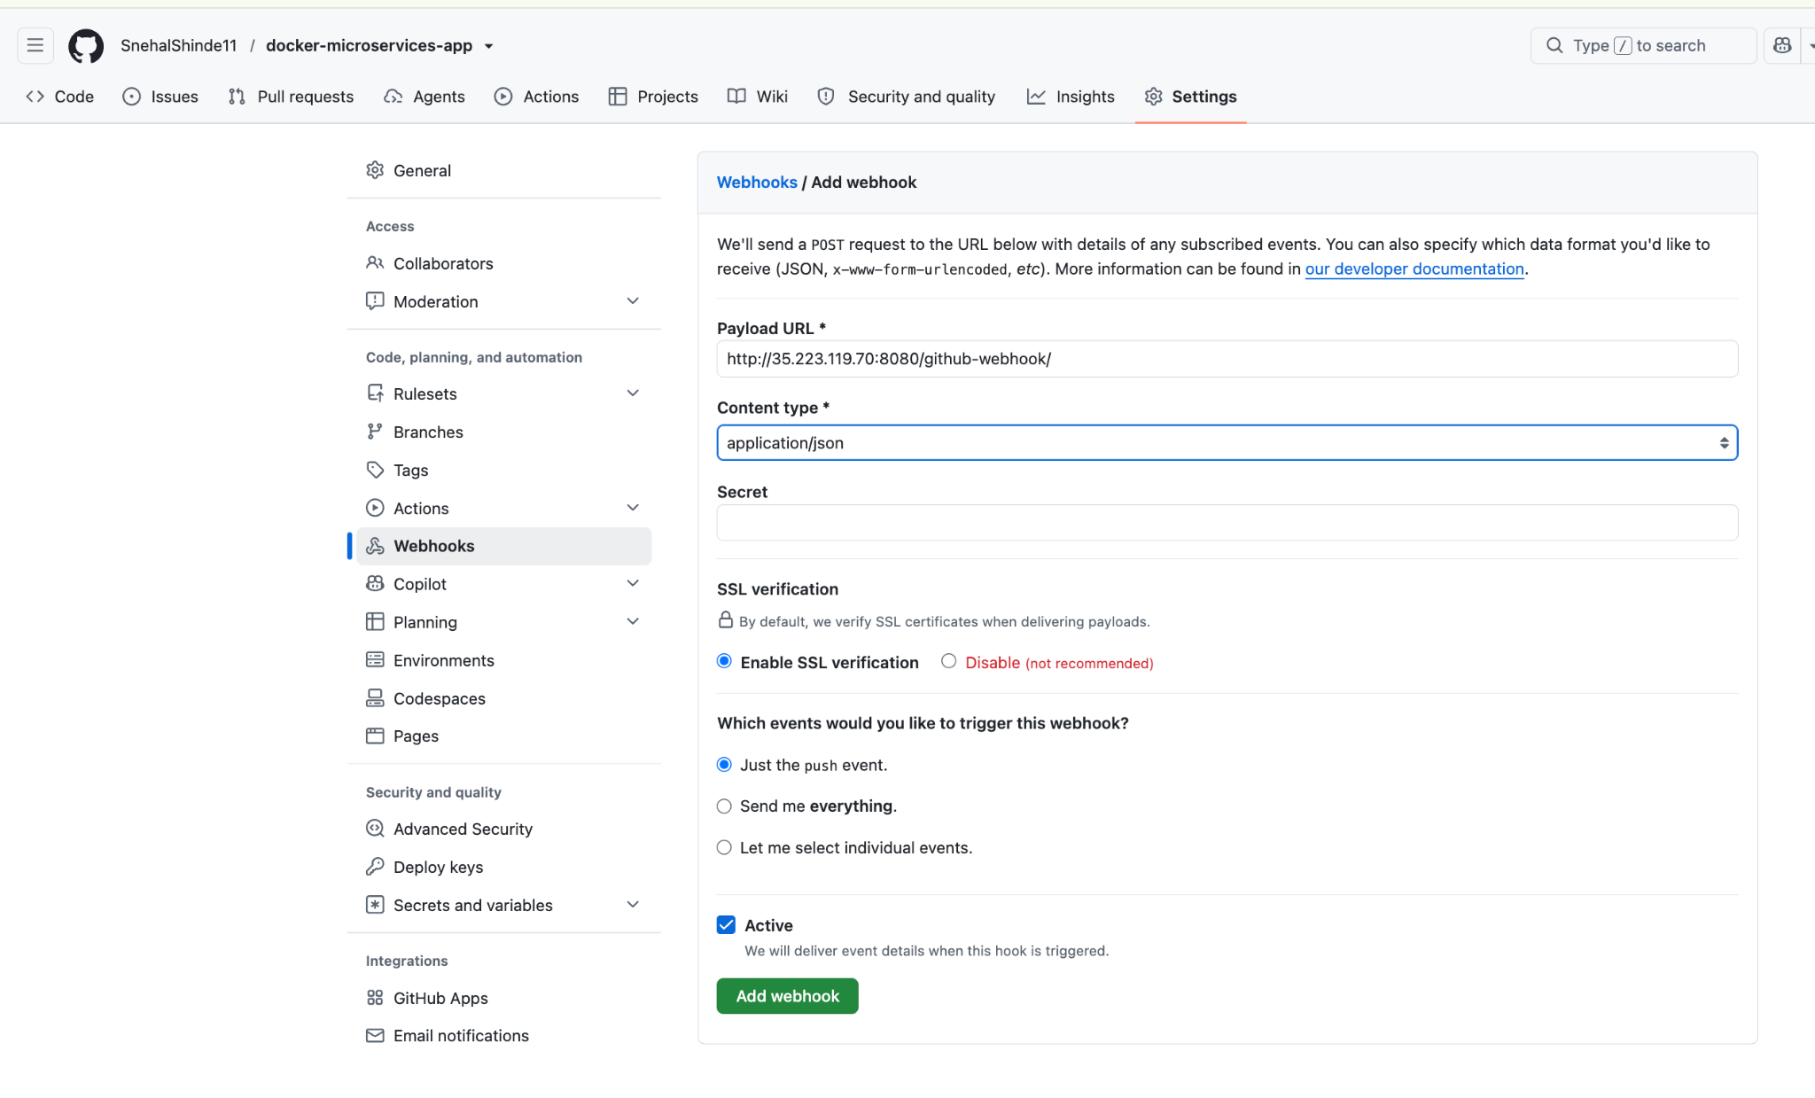

For a webhook test, make a small harmless change to the backend application so we can clearly see a new Git commit trigger Jenkins.
Change
Change the response text in backend/main.go.
Current: fmt.Fprintln(w, "Backend Service is running")
Change it to: fmt.Fprintln(w, "Backend Service is running - Jenkins Webhook Test")
Using this commands:
#cd ~/microservices-app
# sed -i 's/Backend Service is running/Backend Service is running - Jenkins Webhook Test/' backend/main.go
# git diff

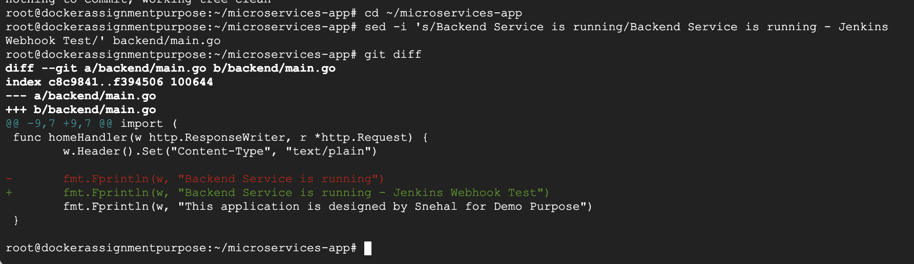
Then :
#git add backend/main.go
#git commit -m "Test GitHub webhook trigger"
#git push origin main

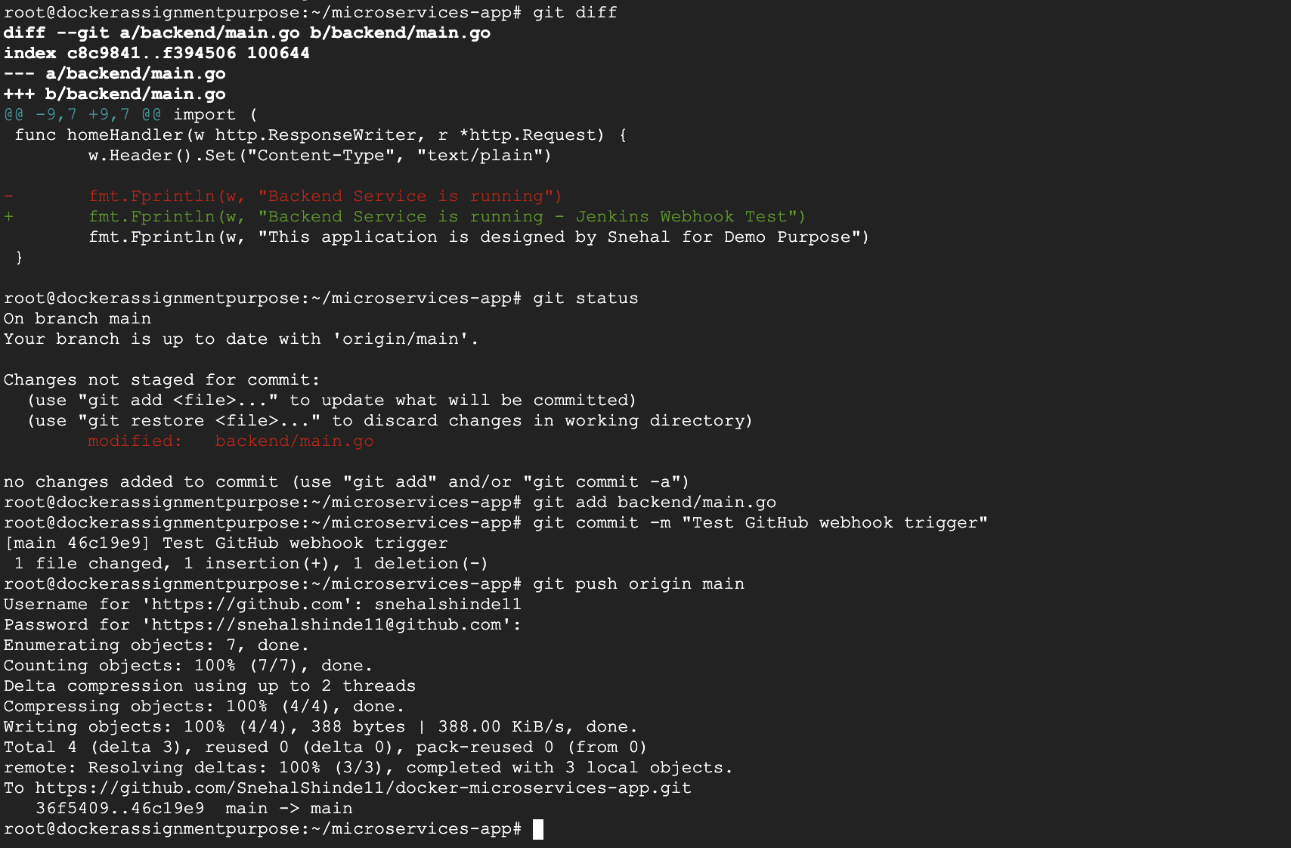
What should happen
After the git push, don't click Build Now.

GitHub should send:
git push
↓
GitHub Webhook
↓
Jenkins
↓
microservices-backend-ci
↓
Build #N automatically starts
In Jenkins, open:
microservices-backend-ci → Build History
In case if won’t auto trigger :
Error : Check in webhook recent deliveries :
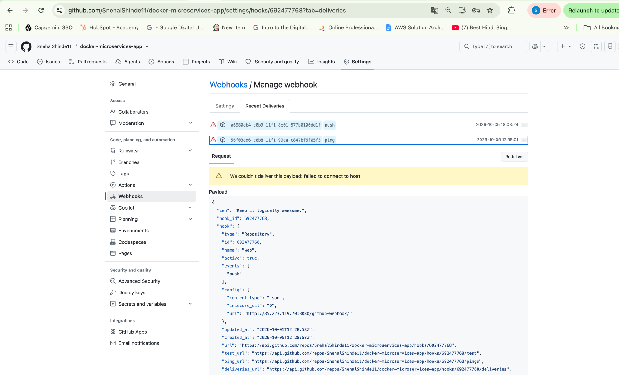
For this we need to temporary modify the firewall rule to allow TCP 8080 traffic from the internet.
Go to firewall rule and edit it as we previously allowed traffic from mac :
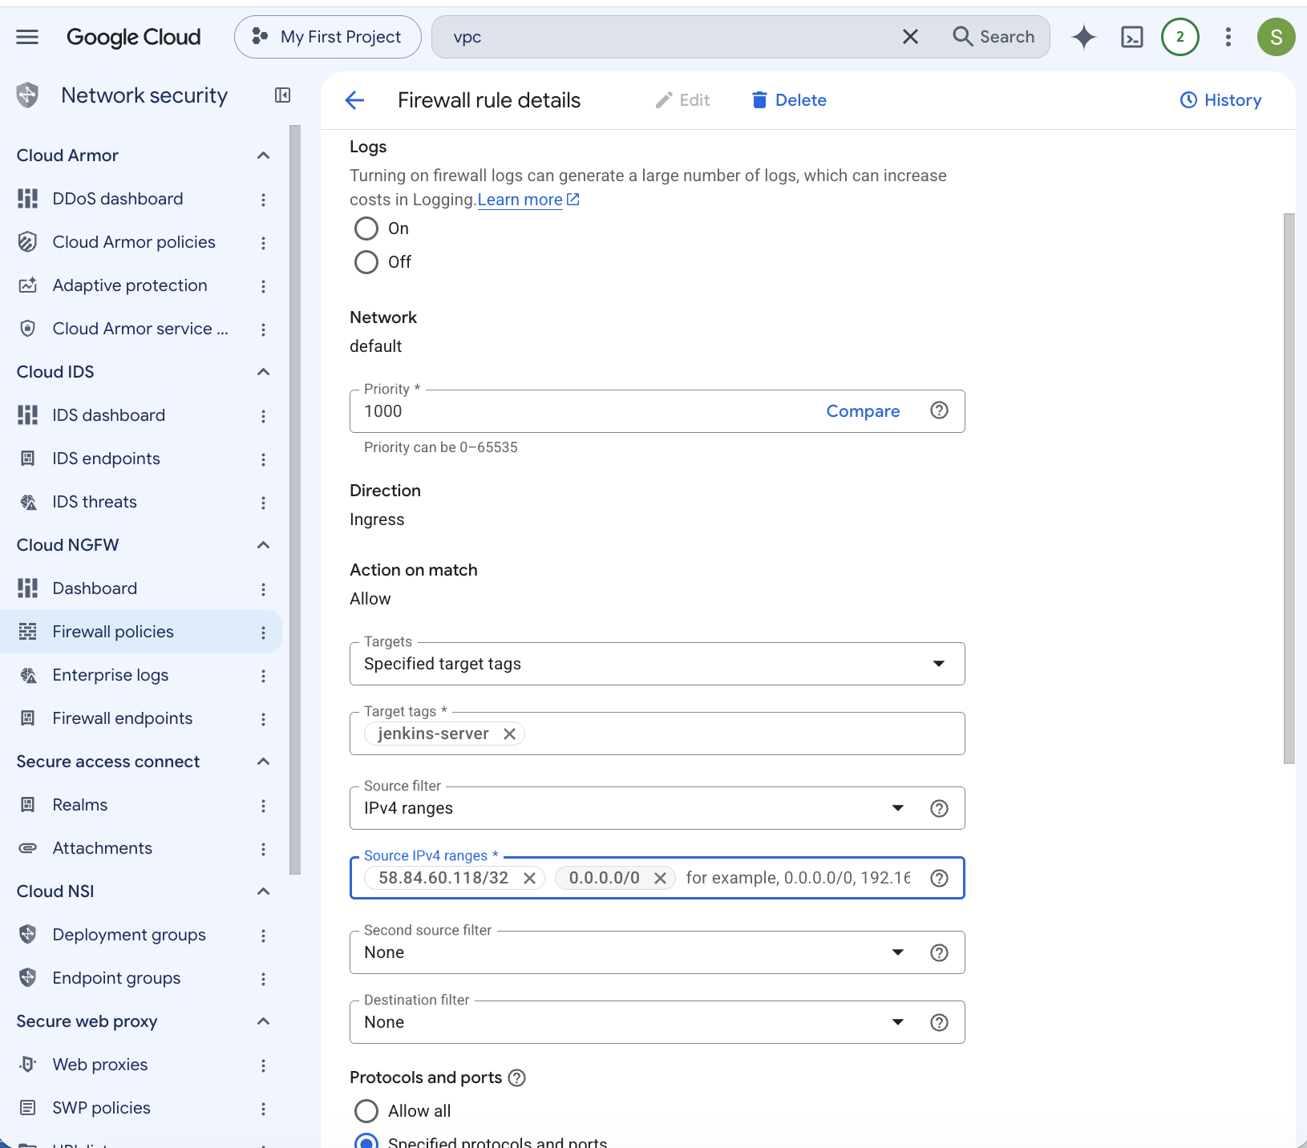

Now again make some changes and then push :

1. Go to your project
cd ~/microservices-app
2. Check current status
git status
You should ideally see:
On branch main
Your branch is up to date with 'origin/main'.
nothing to commit, working tree clean
3. Make a small change
Let's change the backend message:
sed -i 's/Backend Service is running/Backend Service is running - Webhook Test/' backend/main.go
4. Verify the change
git diff
You should see something similar to:
- fmt.Fprintln(w, "Backend Service is running")
+ fmt.Fprintln(w, "Backend Service is running - Webhook Test")
5. Add the change
git add backend/main.go
Check:
git status
You should see:
Changes to be committed:
modified: backend/main.go
6. Commit
git commit -m "Test Jenkins GitHub webhook"
7. Push to GitHub
git push origin main
You should get something similar to:
To https://github.com/SnehalShinde11/docker-microservices-app.git
xxxxxxx..yyyyyyy main -> main
8. Don't click Build Now
Now wait around 10–30 seconds.
Go to:
Jenkins → microservices-backend-ci → Build History
You should see a new build automatically appear.

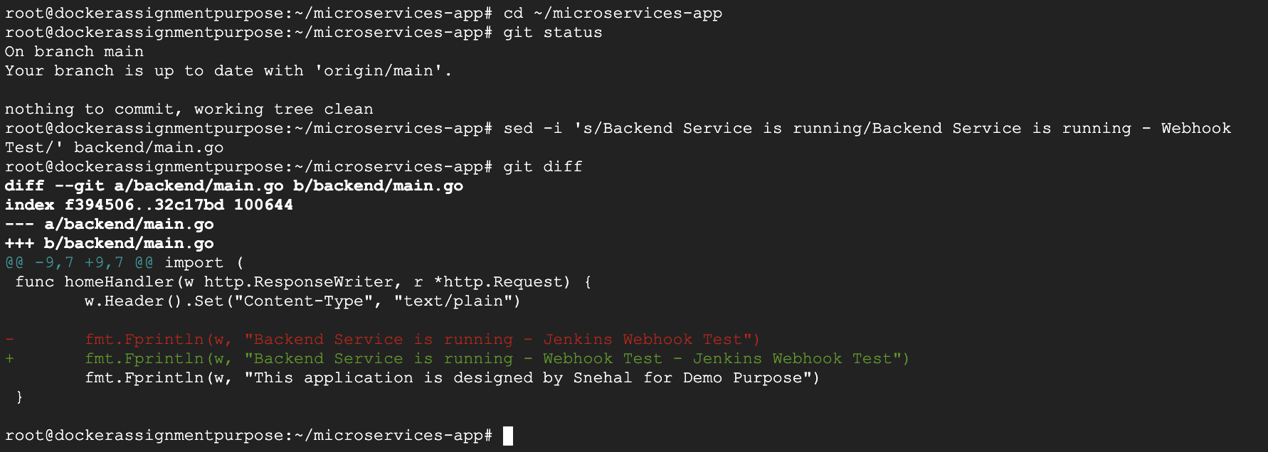

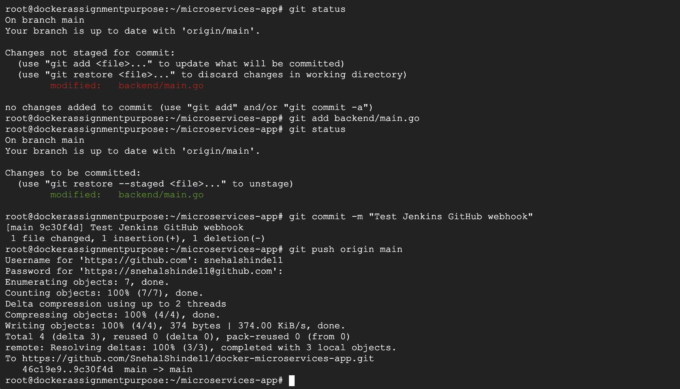

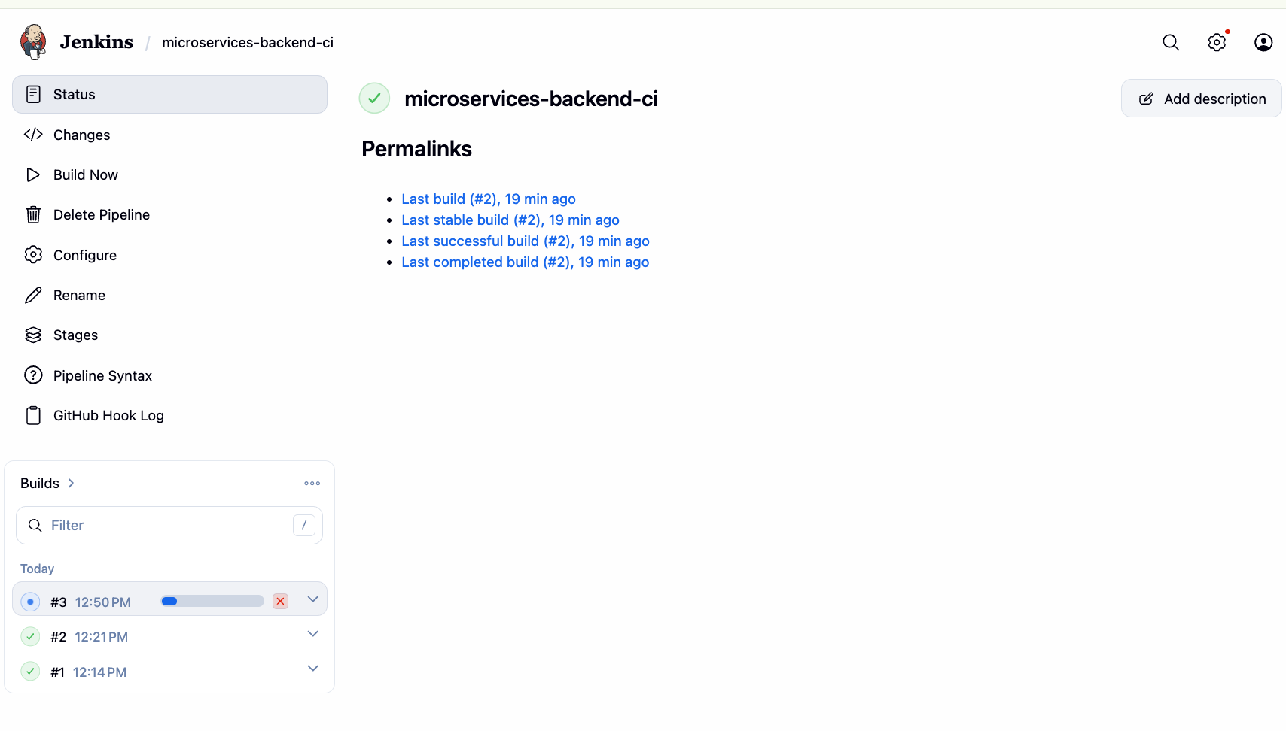

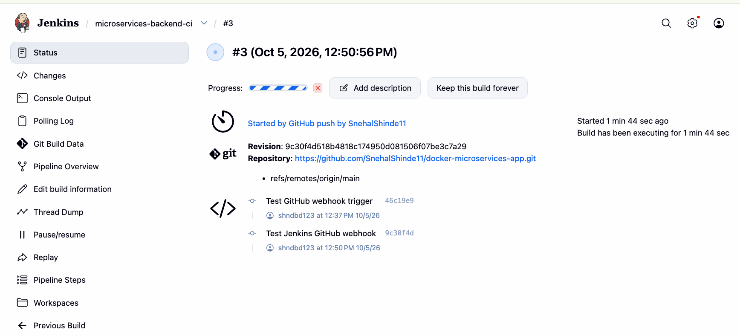

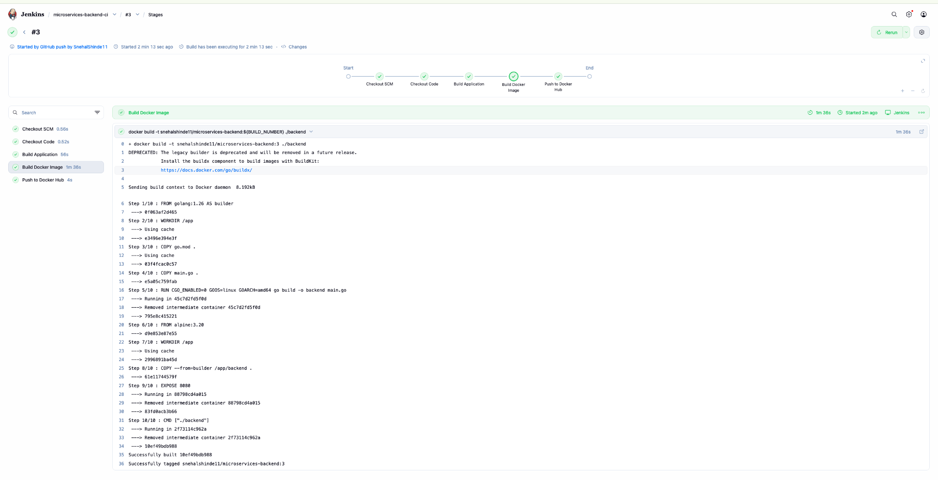

Configure Jenkins to automatically trigger the pipeline using a GitHub webhook whenever new code is pushed to the repository.

Docker image version tagging :

Below Section from Jenkinsfile fulfills this task :
stage('Build Docker Image') {
steps {
sh '''
docker build \
-t snehalshinde11/microservices-backend:${BUILD_NUMBER} \
./backend
'''
}
}

Modify the pipeline to tag Docker images using the Jenkins build number to maintain unique image versions.

Below Highlights section covers this requirement.

stage('Push to Docker Hub') {
steps {
withCredentials([
usernamePassword(
credentialsId: 'dockerhub-creds',
usernameVariable: 'DOCKER_USERNAME',
passwordVariable: 'DOCKER_PASSWORD'
)
]) {
sh '''
echo "$DOCKER_PASSWORD" | docker login \
--username "$DOCKER_USERNAME" \
--password-stdin

docker push \
snehalshinde11/microservices-backend:${BUILD_NUMBER}

docker logout
'''
}
}
}

Pipeline stage visualization.
Jenkins normally provides Stage View for Pipeline jobs through the Pipeline Stage View functionality/plugin.
After running the pipeline:
Go to:
Jenkins → microservices-backend-ci

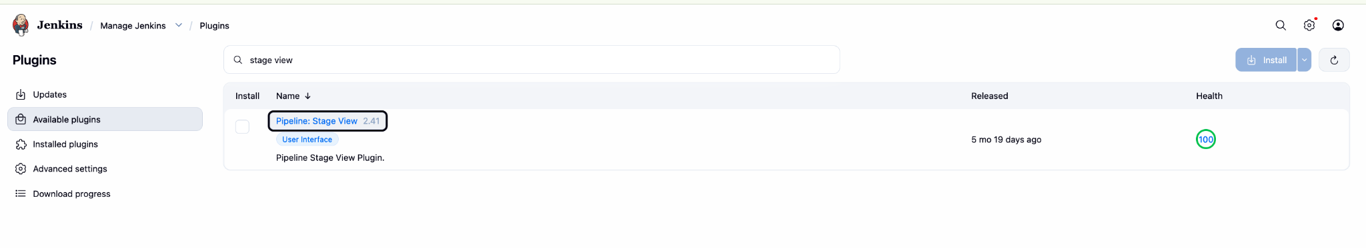

Enable Jenkins Stage View to clearly visualize each pipeline stage during execution.
Manage Jenkins → Plugins → Installed
Search for:
Pipeline: Stage View

Once installed run the build once again :

